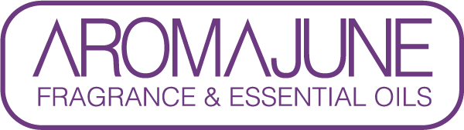

DATE : {{DATE}}
TO : {{CUSTOMER}}
SUBJCET : Natural Organic Index (ISO 16128)
PRODUCT NAME : {{PRODUCT}}

AROMAJUNE hereby confirms that the natural and organic indices of the above mentioned product have been calculated in accordance with the definitions of ISO 16128-1:2016 and the calculation method of ISO 16128-2:2017, to the best of our knowledge.

The resulting indices are as follows:
Natural index | Natural origin index | Organic index | Organic origin index
0 | 0 | 0 | 0



